THE VERTEBRATES 1: FISH!!!
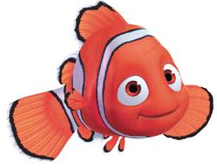Fish, fish, and more fish! There are more kinds of fish in the world than all the other vertebrates added together! Fish can be beautiful or ugly. They can be big or small. They can be colourful or dull. They are pretty and interesting to watch.
Even though fish are very different from each other, they do have 3 important things in common. First, they are vertebrates, so they have a backbone. They are water animals and spend all their time in the water! Fish breathe with gills instead of lungs like other vertebrates.
Fish are cold-blooded, which means that the temperature of their bodies changes with the temperature of the water around them! Fish are found in very warm waters and in the very cold waters of the Arctic. Some fish travel long distances. They are excellent swimmers!
Some fish have scales to protect them. Almost all fish have fins which help them swim.
Fish hatch from eggs. When fish hatch, they are called larvae!
Fish Comprehension Sheet
A. Use the reading sheet to help you answer the questions:
1. Where do all fish live?
2. What do fish use to breathe with?
3. What are fish called when they hatch?
4. Write the four most important things you read about fish:
B. What is the meaning of...
-Gills
- hatch
- lungs
- backbone

