ÀREA: CIÈNCIES NATURALS

TOPIC: CELLS

Activity 1.
Read the information about cells on this website and then answer the questions.

What characteristic is common to all cells?

Name four jobs cells can do:

- …………………………………………………………………………………
- …………………………………………………………………………………
- …………………………………………………………………………………
- ………………………………………………………………………………

What do you learn about the size of cells?

All cells have got three basic parts. What are they? What are their functions? Complete the table with the correct information.

PART | FUNCTION

The organelles are the tiny organisms inside the cell that perform various jobs. What are their names and functions?

NAME | FUNCTION

Activity 2.
TEACHERS: This is interactive activity. Students should do it on a computer either at home or at school and then copy the result in their notebooks. http://wsgfl2.westsussex.gov.uk/aplaws/intergames/sec_science/Cells.swf

Let’s see whether you can complete all the cells in this game. When you have completed each cell draw it on this sheet of paper or in your notebook. Don’t forget to colour and label all the different parts

ANIMAL CELL | PLANT CELL
RED BLOOD CELL | NERVE CELL
PALISADE CELL | SPERM CELL

Activity 3.

LABEL THE NEURON: Read the definitions, then label the neuron diagram below.

axon - the long extension of a neuron that carries nerve impulses away from the body of the cell.  axon terminals - the hair-like ends of the axon  cell body - the cell body of the neuron; it contains the nucleus (also called the soma)  dendrites - the branching structure of a neuron that receives messages (attached to the cell body) | myelin sheath - the fatty substance that surrounds and protects some nerve fibres  node of Ranvier - one of the many gaps in the myelin sheath - this is where the action potential occurs during saltatory conduction along the axon  nucleus - the organelle in the cell body of the neuron that contains the genetic material of the cell  Schwann's cells - cells that produce myelin - they are located within the myelin sheath.

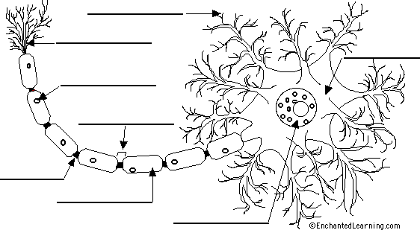

Read the definitions again and then write in their functions without looking back. If you need more help, this game may be useful.

CELL PART | FUNCTION
AXON
NUCLEUS
SCHWANN’S CELLS
DENDRITES
MYELIN SHEATH

Activity adapted from EnchantedLearning.com and worsleyschool.net

