ÀREA: CIÈNCIES NATURALS/GEOGRAPHY
TOPIC: NATURAL FEATURES AND GEOGRAPHY.

You are going to watch a BBC video called Natural Wonders. In it you will see some of the most beautiful natural places and landscapes in the world. Follow the instructions carefully and enjoy the trip.

Before watching the video:

Think about places all over the world that may appear on the video. Write them in the correct column of this table and say what they are (mountains, volcanoes, islands, etc.). Don’t worry if you don’t remember many places, you classmates may know a lot!

AMERICA |  | EUROPE |  | ASIA |  | AFRICA |  | OCEANIA |  | ANTARCTICA
Name | What is it? | Name | What is it? | Name | What is it? | Name | What is it? | Name | What is it? | Name | What is it?

Let’s watch the video now. Read the questions carefully before every segment or scene is played and try to find the answers to the questions. We are sure you can answer some of them without watching the video. Then check your answers when the teacher plays the video for you.

INTRODUCTION

Find the answers to these questions.
Our planet was born of ……………………………….. .
What forces of nature helped to shape our planet?
What is the name of the natural process that has caused this “dramatic story of continuous change” in the world?
How many of the places shown in the introduction can you recognise?

SEGMENT ONE: North America
Fill in the map with the names of the places that are mentioned in the video.

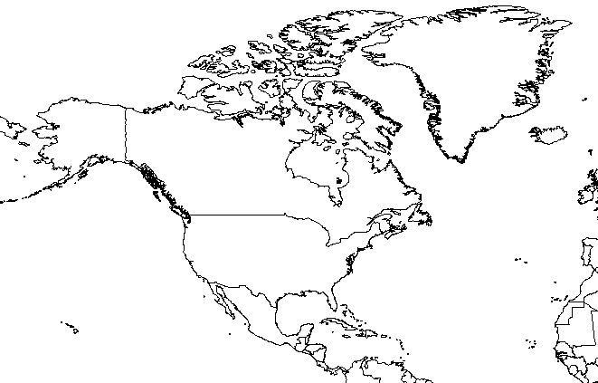

Fill in the table with the correct data about each place.

PLACE NAME | NATURAL FEATURES | SITUATION
Death Valley
Yellowstone
The Rocky Mountains
Monument Valley
Bryce Canyon
Grand Canyon
Carlsbadt
Yosemite

Short questions on the segment:
What is Old Faithful? ………………………
Only one living being can survive in the waters of Morning Glory pool. What is it? ………………………
What yellow substance gives Yellowstone its name? ………………………
What substances give National Monument Valley its colour? ………………………
What are Hoodoos? What did the Indians think they were? ………………………
How long, wide and deep is the Colorado Grand Canyon?
What is Half Dome? ………………………

SEGMENT TWO: South America

Fill in the map with the names of the places that are mentioned in the video.

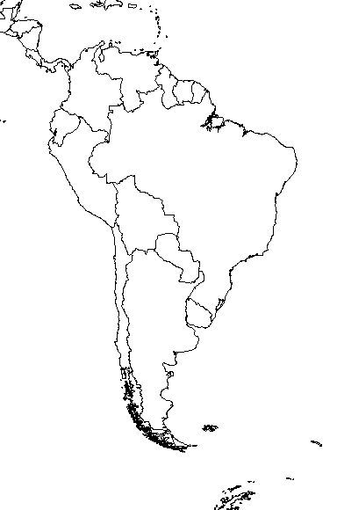

Map from about.com

Fill in the table with the correct data about each place.

PLACE NAME | TYPE OF NATURAL FEATURE | SITUATION
Angel Falls
Iguazú Falls
The Amazon
The Andes
The Moreno

Short questions on the segment:
What makes South America different from the other continents?
What gave Angel Falls its name?
What is Parana?
How large and high is the Amazon basin?
What is Torres del Paine?
There’s one natural phenomenon that is only taking place in South America. What is it?

SEGMENT THREE: The Pacific Ocean

Fill in the map with the names of the places that are mentioned in the video.

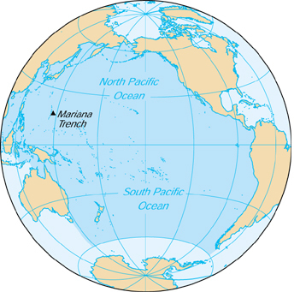

Map of the Pacific Ocean from http://about.com

Short questions on the segment:
What are the origins of the Hawaiian Islands?
How old and high is Big Island in Hawaii?
What is an atoll? How does it form?
What may happen to them in the future?

SEGMENT FOUR: ASIA

Fill in the map with the names of the places that are mentioned in the video.

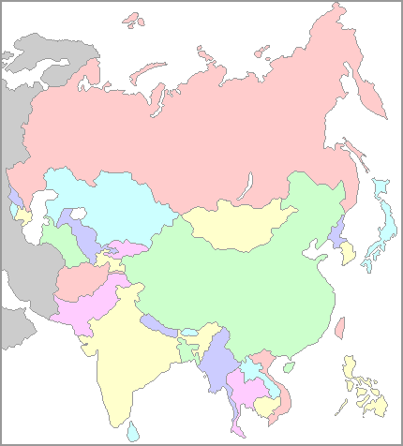

Map of Asia from http://www.yourchildlearns.com/asia_map.htm

Fill in the table with the correct data about each place.

PLACE NAME | NATURAL FEATURES | SITUATION
The Himalayas
Fuji
Guaili

Short questions on the segment:
What is the most populated country in the world?
How old are the Himalayas?

SEGMENT FIVE: EUROPE AND AFRICA.

EUROPE
Fill in the map with the names of the places that are mentioned in the video.

Map of Europe from http://www.yourchildlearns.com/europe_map.htm

Fill in the table with the correct data about each place.

PLACE NAME | NATURAL FEATURES | SITUATION
The Alps
The Rhine
The Rhone
The Danube
Abisko

Short questions on the segment:
What is Mont Blanc?
And “the most noble rock of Europe”?
What natural phenomenon can you see when you are close to the North Pole? Can you explain it?
What happens in Abisko in the summer?

AFRICA
Fill in the table with the correct data about each place.
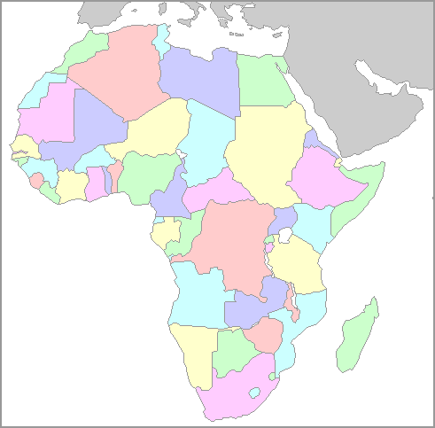

Map of Africa from http://www.yourchildlearns.com/africa_map.htm

Fill in the table with the correct data about each place.

PLACE NAME | NATURAL FEATURES | SITUATION
Kilimanjaro
Serengeti
Ngorongoro
The Rift
Victoria
Namib

Short questions on the segment:
What makes Africa so different from other continents?
What is Serengeti particularly famous for?
What is Zambezi?
Apart from its beauty, why is Namib so attractive to human beings?

SEGMENT SIX: OCEANIA.

Fill in the map with the names of the places that are mentioned in the video.
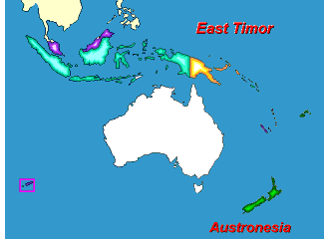

Map of Oceania from http://www.yourchildlearns.com/australia-map-puzzle.htm

Fill in the table with the correct data about each place.

PLACE NAME | NATURAL FEATURES | SITUATION
The Olgas
Uluru or Ayers Rock
The Kimberlies
The Bungle Bungles
The Great Barrier Reef
Mount Cook
Milford Sound

Short questions on the segment:
What makes Australia different from the other continents?
What’s happening to the southern coast of Australia?
What natural phenomenon is particularly active in the northern coast of Australia?
What is The Outback?
How long is The Great Barrier Reef?
What is coral?
What contrasts New Zealand and Australia?

SEGMENT SEVEN: ANTARCTICA.
Choose the correct answer:
Antarctica contains…
- 17% of the world’s water.
- 7% of the world’s water.
- 70% of the world’s water.
In Antarctica…
- there’s no summer.
- summers are short.
- summers are long and hot.
Antarctica is an example of…
- what our planet will look like in the future.
- what our planet looked like in the past.
- a hospitable continent.
Humpback whales…
- don’t like travelling.
- always live in Antarctica and the Arctic.
- live both in Antarctica and the Arctic and the tropics.

After watching the film activities:
What manmade wonders do you remember having seen in the film?

If you want to ‘visit’ some of these places, try and find some of them on Google Earth maps (with satellite views).

