ÀREA: CIÈNCIES NATURALS

TOPIC: THE HUMAN SKELETON

The skeleton is the framework of all the bones in a human or animal body. The bones are the hard parts of the body, which protect the organs inside and round which are the flesh and skin.

After these two basic concepts, let’s learn the names of the bones that shape the human skeleton. If you are working on line, do so on this page. Then complete the following chart with the bones and joints, if there are any, that form each part.

PART | BONES | JOINTS | FUNCTION
Skull

Ribcage

Leg

Arm

Hands

Pelvis

Spine

Teeth

Feet

When your chart has been filled with all the information, choose one or two bones and tell your classmates the most important information about them. The other students must take down the information you give them. Be ready to do the same with 'their bones'.

If you are working on line, when you have finished you may try to ‘assemble’ the interactive skeleton.

Finally, identify all the bones in this picture. This address will help you if you are working on line:
http://en.wikipedia.org/wiki/Image:3DScience_human_skeleton_labeled.jpg

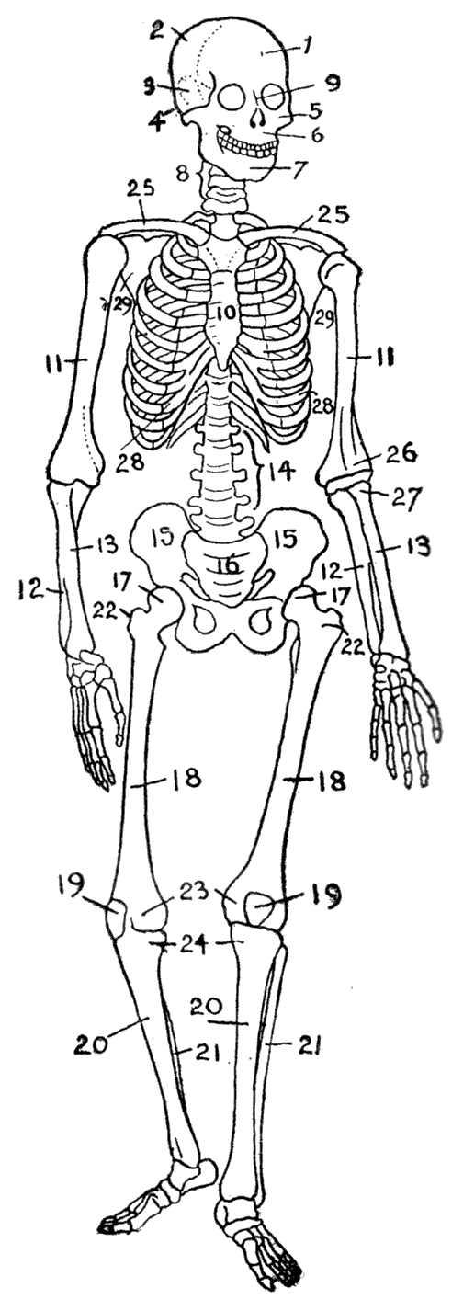 | - ………………………………  - ………………………………  - ………………………………  - ………………………………  - ………………………………  - ………………………………  - ………………………………  - ………………………………  - ………………………………  - ………………………………  - ………………………………  - ………………………………  - ………………………………  - ………………………………  - ………………………………  - ………………………………  - ………………………………  - ………………………………  - ………………………………  - ………………………………  - ………………………………  - ………………………………  - ………………………………  - ………………………………  - ………………………………  - ………………………………  - ………………………………  - ………………………………  - ………………………………

Picture from Wikipedia.

