ÀREA: CIÈNCIES SOCIALS

TOPIC: THE CONTINENTS AND THE OCEANS

WORKSHEET

Continents and Oceans Quiz | Geography Pages
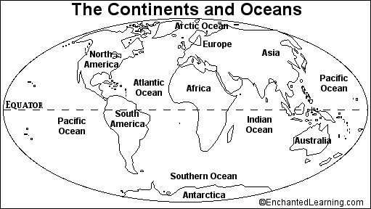
1. What are the five oceans on Earth? _________________________,
_________________________, _________________________,
_________________________, and _________________________.
2. What are the seven continents on Earth? _________________________,
_________________________, _________________________,
_________________________, _________________________,
_________________________, and _________________________,
3. Colour the oceans and seas blue.
4. Colour the continents green.
5. Draw a red line along the equator.

Activity from EnchantedLearning.com

