ÀREA: CIÈNCIES SOCIALS
TOPIC: THE CONTINENTS

WORKSHEET

Label the Continents | Continents Quiz  Geography
Read the definitions, then label the map below.
Definitions

Africa - a continent that crosses the equator. It is south of Europe and is bordered by the Atlantic and Indian Oceans.  Antarctica - the continent that surrounds the South Pole of the Earth.  Asia - a continent in the Northern Hemisphere. Asia is attached to Europe (and east of it).  Australia - a continent, an island, and a country in the Southern Hemisphere.  equator - an imaginary line that divides the Earth into Northern and Southern Hemispheres. | Europe - a continent in the Northern Hemisphere. Europe is attached to Asia (and west of it).  North America - a continent in the Northern Hemisphere; it is north of South America. It is bordered by the Atlantic and Pacific Oceans.  North Pole - the point that is the farthest north on Earth.  South America - a continent that is mostly in the Southern Hemisphere. It is bordered by the Atlantic and Pacific Oceans.  South Pole - the point that is the farthest south on Earth.

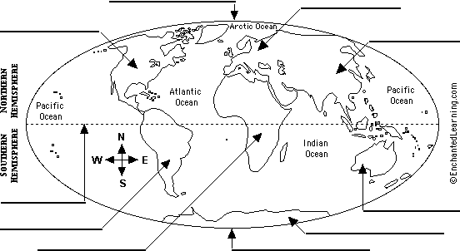

Activity from EnchantedLearning.com

