ÀREA: MÚSICA

TOPIC: THE BLUES

When you answer the following questions it might be useful to consult the following website on the internet: http://en.wikipedia.org/wiki/Blues

Other interesting webs:
http://www.thebluehighway.com/
http://www.bluesworld.com/

Warm-up activity:
First of all, think about the word BLUES, what does it suggest you? What do you know about it? Have you ever heard a ‘blues’? Where?

A. THE ORIGINS.
All music styles have a background, that is to say, they are born from other music styles and are set in a historical context. Where does Blues come from? What were its music sources and its social and cultural background?

Music sources | ……………………………………………………  ……………………………………………………  ……………………………………………………  ……………………………………………………
Social and cultural background | ……………………………………………………  ……………………………………………………  ……………………………………………………  ……………………………………………………

B. THE INSTRUMENTS:
What is the basic blues band formation as regards instruments?

Which of these instruments are not usually to be found when we talk about Blues? Cross them out.

Accordion Trumpet Electric guitar Spanish guitar Trombone Banjo Piano Acoustic guitar Harmonica Flute
Clarinet Violin Drums Bass Synthesizers Organ Harp Pipes Cello Mandolin

Get some information about these terms closely related to the Blues style. What are they?

 | What is it? | Picture
DOBRO/RESONATOR
SLIDE
BOTTLENECK
GUT BUCKET

C. THE SONGS:

Let’s have a look at the lyrics now. Which of these topics are usual in BLUES? Underline them.

DISCOS SEX DRUGS LOVE
SOCIAL INJUSTICE HUMAN RIGHTS SCHOOL HAPPINESS, POLITICS WOMEN’S RIGHTS LONELINESS RACISM COUNTRY LIFE CITY LIFE

Most Blues have got a very clear and typical structure. Listen to a typical blues song (for example, Crawling’ Kingsnake by Muddy Waters). Can you describe its structure?

D. THE GEOGRAPHY:
Look at this map of the USA. Tick the places where these blues men were born, lived and worked. What are your conclusions?
John Lee Hooker, Muddy Waters, Robert Johnson, Howling Wolf, Leadbelly, B.B. King.
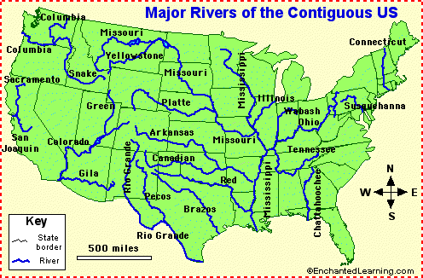

E. THE MUSICIANS.

E.1. The following names are very popular blues musicians, but they have very different origins and lived in different times (some of them are still alive!). Could you fill in the chart with the correct data?

NAME | Nationality | Race | Time span | Instrument

John Mayall
B.B. King
Johnny Winter
Leadbelly
Robert Johnson
Gary Moore
Howlin’ Wolf
Dr. John
Sonny Boy Williamson
John Lee Hooker
Paul Butterfield
Freddie King
Eric Clapton
Mike Bloomfield
S.R. Vaughan
Ronnie Hawkins
Memphis Meannie
Ray Charles
Peter Green

E.2. The world of Blues was mostly a male world, but there were also some brave women who played a very important role in its history. Could you mention at least one for each period?

Pre-war blues 1920’s-1930’s
Post-war blues 1940’s-1950’s
1960’s
1970’s
1980’s
1990’s
2000’s

E.3. A lot of Blues players used ‘beautiful’ nicknames. What are the real names behind these pseudonyms? Think about the meaning of their ‘artistic’ names. Any relationship with the Blues spirit?

MUDDY WATERS
HOWLIN’ WOLF
LEADBELLY
MEMPHIS MEANNIE
MEMPHIS SLIM

PROFESSOR LONGHAIR

F. A few questions to make you think:
F.1. When you read the lives of blues men and women you realise that most of them did not even go to school. How do you think they learnt to play music? What was their “school”?

F.2. Do you think that Blues and Flamenco have something in common?

