ÀREA: MUSIC

TOPIC: COUNTRY MUSIC

When you answer the following questions it might be useful to consult the following web page on the Internet: http://en.wikipedia.org/wiki/Country_Music

Warm-up activity:
First of all, think about the word COUNTRY, what does it suggest you? What do you know about it? Have you ever heard ‘country’ music? Where?

A. THE ORIGINS.
All music styles have a background, that is to say, they are born from other music styles and are set in a historical context. Where does Country come from? What were its music sources and its social and cultural background?

Music sources | ……………………………………………………  ……………………………………………………  ……………………………………………………  ……………………………………………………
Social and cultural background | ……………………………………………………  ……………………………………………………  ……………………………………………………  ……………………………………………………

B. THE INSTRUMENTS:
B.1. What is the basic country band formation according to instruments?

B.2. Which of these instruments are not usually to be found when we talk about Country music? Cross them out.
Accordion Trumpet Electric guitar Spanish guitar Trombone Banjo Piano Acoustic guitar Harmonica Flute
Clarinet Violin Drums Bass Synthesizers Organ Harp Pipes Cello Mandolin

B.3. These words are instruments closely related to the country style. Get some information about them and then draw them:

DOBRO/RESONATOR | SLIDE | LAP/STEEL GUITAR | WASHBOARD

C. THE MUSIC:
Have a look at the structure of a typical Country song. Can you describe it? What are the usual rhythms of Country music?
Examples: Lost on the River (Hank Williams), I Hold the Line (Johnny Cash), Crazy (Patsy Cline), Stand by Your Man (Tammy Wynette).

Let’s pay attention to the lyrics now. Underline the topics which are usual in Country.

DISCOS SEX DRUGS LOVE
SOCIAL INJUSTICE HUMAN RIGHTS SCHOOL HAPPINESS, POLITICS WOMEN’S RIGHTS LONELINESS RACISM COUNTRY LIFE CITY LIFE

The next song was a big hit some time ago and is still one of the most popular country songs ever. It was sung by Tammy Wynette. However, some people dislike it very much. The problem is the lyrics. Read it and then discuss what the problem is with your classmates. Relate it to the previous exercises.

Sometimes it's hard to be a woman
Giving all your love to just one man
You'll have bad times

And he'll have good times
Doing things that you don't understand
But if you love him you'll forgive him
Even though he's hard to understand
And if you love him
Oh be proud of him
'Cause after all he's just a man

Stand by your man
Give him two arms to cling to
And something warm to come to
When nights are cold and lonely
Stand by your man
And show the world you love him
Keep giving all the love you can
Stand by your man
Stand by your man
And show the world you love him
Keep giving all the love you can
Stand by your man

D. THE GEOGRAPHY:
Look at this map of the USA. Tick the places where these Country singers were born, lived and worked. What are your conclusions?
Jimmy Rodgers, Hank Williams, The Carter Family, Johnny Cash, Willie Nelson, Patsy Cline, Merle Haggard, Waylon Jennings, Faron Young, Tammy Wynette, Dolly Parton, Emmylou Harris.

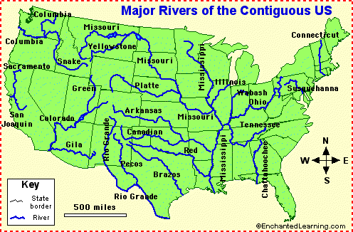

E. THE MUSICIANS.

Complete the table with the correct data. What are your own conclusions?

NAME | TIME SPAN | RACE | MUSIC STYLE | STATE
Jimmy Rodgers
Hank Williams
Merle Haggard
Nanci Griffith
Johnny Cash
Willie Nelson
June Carter
Gram Parsons
Garth Brooks
Kenny Rogers
Lucinda Williams
Waylon Jennings
Faron Young
Garth Brooks
Dwight Yoakam
Loretta Lynn
Dolly Parton
Tammy Wynette
Patsy Cline
Kenny Rogers

The Carter Family started a very important saga in the history of Country Music. Could you draw their family tree?

F. GENERAL QUESTIONS

These are words related to country music. What do they mean?

Bluegrass
Honky Tonk
Zydeco
Cajun

Country music has usually been related to Rednecks. Who are they and what are the cultural, social and political connotations? What are your personal conclusions?

