ÀREA: MÚSICA
TOPIC: JAZZ

When you answer the following questions it might be useful to consult the following website on the Internet: http://www.en.wikipedia.org/wiki/jazz

Warm-up activity:
First of all, think about the word JAZZ, what does it suggest you? What do you know about it? Have you ever heard ‘Jazz’? Where?

A. THE ORIGINS.
All music styles have a background, that is to say, they are born from other music styles and are set in a historical context. Where does Jazz come from? What were its music sources and its social and cultural background?

Music sources | ……………………………………………………  ……………………………………………………  ……………………………………………………  ……………………………………………………
Social and cultural background | ……………………………………………………  ……………………………………………………  ……………………………………………………  ……………………………………………………

B. THE INSTRUMENTS:
What is the basic jazz band formation according to instruments?

Which of these instruments are not usually to be found when we talk about Jazz? Cross them out.
Accordion Trumpet Electric guitar Spanish guitar Trombone Banjo Piano Acoustic guitar Harmonica Flute
Clarinet Violin Drums Bass Synthesizers Organ Harp Pipes Cello Mandolin

C. THE MUSIC:
C.1. The Lyrics:
Let’s have a look at the lyrics now. Which of these topics are usual in JAZZ?

DISCOS SEX DRUGS LOVE
SOCIAL INJUSTICE HUMAN RIGHTS SCHOOL HAPPINESS, POLITICS WOMEN’S RIGHTS LONELINESS RACISM COUNTRY LIFE CITY LIFE

C.2. The Songs:
Listen to this song called Strange Fruit and pay attention to the lyrics. What is it about? Can you describe its structure?

Southern trees bear strange fruit,
Blood on the leaves and blood at the root,
Black bodies swinging in the southern breeze,
Strange fruit hanging from the poplar trees.
Pastoral scene of the gallant south,
The bulging eyes and the twisted mouth,
Scent of magnolias, sweet and fresh,
Then the sudden smell of burning flesh.
Here is fruit for the crows to pluck,
For the rain to gather, for the wind to suck,
For the sun to rot, for the trees to drop,
Here is a strange and bitter crop.

Did you like it? It’s sung by one of the most popular singers in the history of Jazz: Billie Holiday. Read about her difficult life on this website: http://concise.britannica.com/ebc/article-9367219/Billie-Holiday.

C.3. Get some information about these English words closely related to the Jazz style:

RAGTIME
DIXIELAND
BEBOP
REEDS
SCAT

D. THE GEOGRAPHY:

Look at this map of the USA and draw the jazz route from its beginnings to the 1940’s. Write the names of the most important cities on the route.

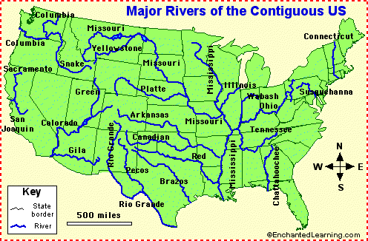

E. THE MUSICIANS.

E.1. The following names are very popular jazz musicians, but they have very different origins and lived in different times (some of them are still alive!). Could you fill in the chart with the correct data?

NAME | Nationality | Race | Time span | Instrument

CHICK COREA
LOUIS ARMSTRONG
DJANGO REINHARDT
TETE MONTOLIU
DUKE ELLINGTON
CHET BAKER
BILLIE HOLIDAY
BENNY GOODMAN
CHARLIE PARKER
STEPHANE GRAPELLI
DIZZY GILLESPIE
JOE HENDERSON
ELLA FITZGERALD
MILES DAVIS
WYNTON MARSALIS
JOHN COLTRANE
KEITH JARRETT
TITO PUENTE
WAYNE SHORTER

E.2. The world of Jazz was mostly a male world, but there were also some brave women who played a very important role in its history. Could you mention at least one for each period?

Pre-war jazz 1920’s-1930’s
Post-war jazz 1940’s-1950’s
1960’s
1970’s
1980’s
1990’s
2000’s

E.3. A lot of Jazz players used ‘beautiful’ nicknames. What are the real names behind these pseudonyms? Think about the meaning of their ‘artistic’ names. Any relationship with the Jazz spirit?

Satchmo
Lady Day
The Voice
Bird
The Little Sparrow
The Sound
The Trane

F. A few questions to make you think:
1. When you read the lives of jazzmen and women you realise that most of them had hard lives and did not even go to school. How do you think they learnt to play music? What was their “school”?

2. Improvisation is a key word in Jazz. What does it tell you about the music and the musicians?

3. Think about all you have learnt here. What are your personal conclusions about Jazz?

