ÀREA: MÚSICA
TOPIC: MUSIC NOTATION

Activity adapted from http://www.lessontutor.com/eesMusic1.html

When we write we need letters, words, sentences, etc. Music has its own language and when we write or read it we must be familiar with some basic items. Have a look at these elements of music notation.

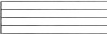 | STAFF | Five parallel, equidistant lines with spaces in between.
BAR LINE  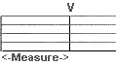 | BAR LINES | Vertical lines placed in a STAFF to mark off MEASURES.
 | MEASURE | Part of a STAFF set off by BAR LINES
Treble Clef Bass Clef | CLEF | Musical symbol that names lines and spaces. There are two: TREBLE and BASS.
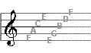 | TREBLE CLEF | Also called the "G" clef. The Lines designate the following notes, in order from the bottom, up : E,G, B, D, F. The spaces are for the notes F, A, C, E, in order from the bottom up.
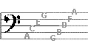 | BASS CLEF | Also called the "F" clef. The lines are labelled G, B, D, F, A. The spaces are called A, C, E, G.
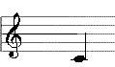  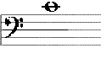 | LEDGER LINES | Lines added above or below the staff. In the picture (left) both notes with ledger lines indicate middle C.
All together: | 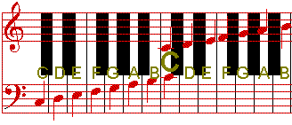

Once you are familiar with the terms do the following exercises on this sheet.

1.a) Label the staff with a treble clef
b) Label the lines on this staff

2.a) Label the staff with a bass clef
b) Label the spaces on this staff

3. Label the keyboard notes:
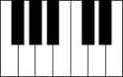
4. If this note were on a treble staff, what note would it be?
If it were on a bass staff, what note would it be? 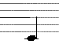

5. If this note were on a treble staff, what note would it be?
If it were on a bass staff, what note would it be? 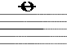

6. Define the following terms:
a) Measure: .………………………………………………………………………………………..
b) Bar: ………………………………………………………………………………………………

After this exercise let’s have a look at the notes. Not all notes are the same length, that is to say, they have different values and that gives them different names. Here is a chart that can help you learn their names and values.

NOTE CHART

NAME | SYMBOL | LENGTH
Whole Note |  | Four beats equal one whole note.
Half Note |  | Two half notes make a whole.
Quarter Note |  | Two quarter notes make a half note  Four quarter notes make a whole note
Eighth Note | 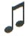 | Two eighth notes = 1 quarter note
Sixteenth Note | 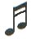 | Two sixteenth notes make one eighth.
Thirty Second Note | 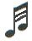 | Two 32nd notes = one sixteenth note

When we play or listen to music there are times when no sound is heard in the middle of a song. We call this rest. There is one for every note.

REST CHART

NAME | SYMBOL | LENGTH
Whole Rest |  | Worth 4 beats, like the Whole Note.
Half Rest |  | Worth 2 beats, like the half note
Quarter Rest |  | Worth one beat, like the quarter note.
Eighth Rest |  | Worth half a beat, like 1 eighth note.
Sixteenth Rest |  | Worth a half an eighth rest.
Thirty Second Rest |  | Worth half of a sixteenth rest.
One last thing you have to learn is the ‘hold’ dot. It’s just a dot placed after a note or a rest and it makes them fifty per cent longer.
The following diagram can help you understand the length of notes a bit better.

Every note group adds up to 4 counts:

Whole
Half
Quarter
Eighth
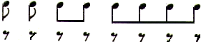
Sixteenth
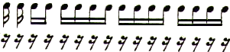

This is how rests are placed on the staff.
An EIGHTH Rest is placed on a staff like this:  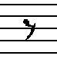  = 1/2 COUNT |  | A QUARTER rest is placed on a staff like this:  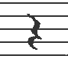  = 1 COUNT |  | A HALF rest is placed above the 3rd staff line like this:  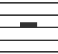  = 2 COUNTS |  | A WHOLE rest is placed below the 4th staff line like this:  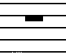  = 4 COUNTS

Now do these exercises.
1. In the columns of blank staffs below, draw one or more rests that get the same number of counts as the notes immediately to the left. Practice drawing the clefs as well.
2. Label the names/location of each note and identify what type of note it is. Use the following abbreviations: Whole note = W, Half note = H, Quarter note = Q, Eighth note = E, Sixteenth note = S
Example.
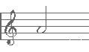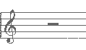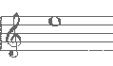
1. A - half note 2. H 3, __________ 4. __________

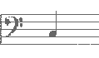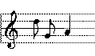
5. ____________ 6. ___________ 7. ___ 8.___ 9.___ 10___ 11___ 12___

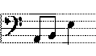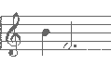
13___ 14___ 15___ 16 ___17___18___ 19 ___ 20___ 21 ___ 22___

Bass clef, W, middle C Treble clef, 2x S, D, E

Solutions

Label the following items:

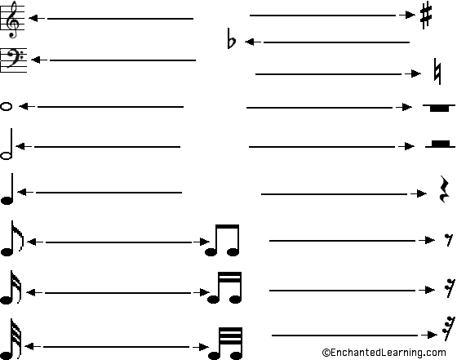

bass clef  treble clef  flat  natural  sharp | eighth note  eighth rest  half note  half rest  quarter note | quarter rest  sixteenth note  sixteenth rest  thirty-second note  thirty-second rest

Activity from EnchantedLearning.com
Label the following items:

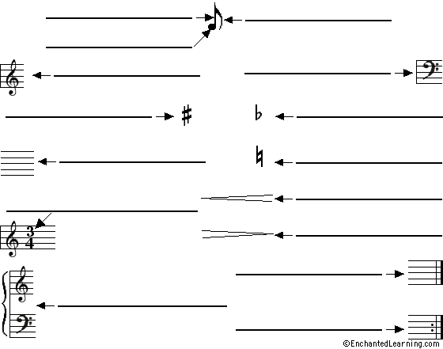

bass clef
crescendo
decrescendo
double bar line
flag
grand staff
head
treble clef
flat
natural
repeat
sharp
staff
stem
time signature

These two exercises are a bit more difficult. Let’s see if you can cope with them.
1. Identify the notes in each of the following 16 measures.

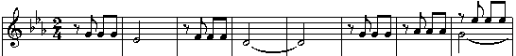

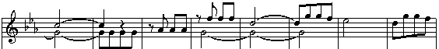

2. What kind of notes and rests are in the following 6 measures.

