ÀREA: MÚSICA
TOPIC: MUSIC THEORY. NOTES AND RESTS.

All these activities can be found on this page:
http://www.enchantedlearning.com/music/theory/

LEARN THE NOTES AND RESTS

Musical Notes and Rests

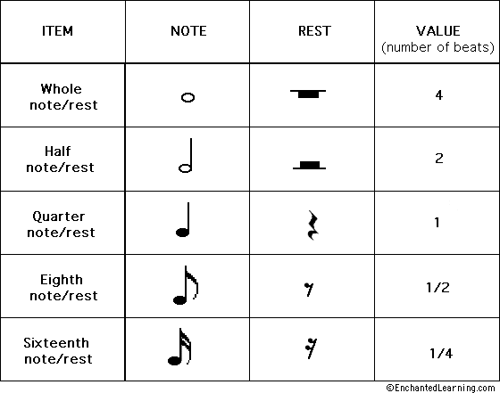

Dotted Musical Notes and Rests

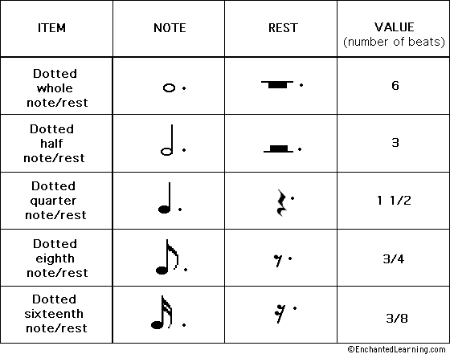

Draw the musical notes and rests and their values and fill in the two tables.

ITEM | NOTE | REST | VALUE
Whole note/rest

Half note/rest

Quarter note/rest

Eighth note/rest

Sixteenth note/rest

ITEM | NOTE | REST | VALUE
Dotted whole note/rest

Dotted half note/rest

Dotted quarter note/rest

Dotted eighth note/rest

Dotted sixteenth note/rest

