ÀREA: VISUAL I PLÀSTICA
TOPIC: COLOUR

STUDENT’S WORKSHEET

Read the following information about colour and do the two activities.

Colour Mixing and the Colour Wheel

It's easy to mix paints to make new colours. You can use the primary colours (red, blue, and yellow) plus black and white to get all of the colours of the rainbow.

Mixing Colours
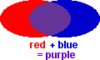 | 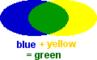 | 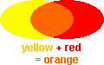
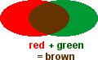 | 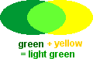 | 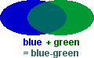

The Colour Wheel:
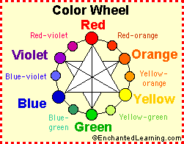
The Colour Wheel shows the relationships between the colours.

The three primary colours are red, yellow, and blue; they are the only colours that cannot be made by mixing two other colours.
The three secondary colours are green, orange, and violet; they are each a mixture of two primary colours. Their hue is halfway between the two primary colours that were used to mix them. On the colour wheel, the secondary colours are located between the colours they are made from.
The six tertiary colours (red-orange, red-violet, yellow-green, yellow-orange, blue-green and blue-violet) are made by mixing a primary colour with an adjacent secondary colour. On the colour wheel, the tertiary colours are located between the primary and secondary colours they are made from.
Black, white and grey are not true colours (or hues). They are considered to be neutral, achromatic colours.
Value refers to how light or dark a colour appears. To make a colour lighter in value, white is added. A light colour is called a tint of the original hue. For example, pink is a tint of red. To make a colour darker in value, black is added. A dark colour is called a shade of the original hue. Maroon is a shade of red.

Making Colours Lighter or Darker

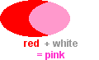  To make a colour lighter in value, add white. The more white you add, the lighter the colour will get. This is called a tint of the original colour. | 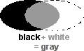  To make a colour darker (this is called a shade of the original colour), add a small amount of black. If you add too much black, your colour will be almost black. Another way to darken a colour is to mix in some of the complementary colour (the opposite colour on a colour wheel - see below). This produces a rich, dark colour (richer than just adding black). Some pairs of complementary colours are: blue/orange, green/red, yellow/purple, black/white.
Intensity refers to the brightness or dullness of a colour. An example is bright red (or dull red).

Colour Schemes (Colour Harmonies):

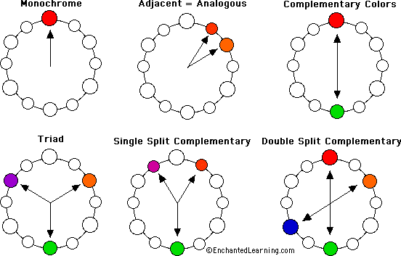

Monochrome (meaning "one colour") colour harmonies include only one colour in different value (the lightness and darkness of a colour) and intensity (the brightness or dullness of a colour). An example of a monochrome colour scheme could include any colour mixed with white, grey, or black. For example, red, rose and pink (red mixed with white) are monochrome.
Adjacent colours (also called analogous colours) uses colours that neighbour each other on the colour wheel. An example is a colour scheme that includes various values and intensities of reds and oranges.
Colours opposite each other on the colour wheel are called complementary colours. For example, violet and yellow are complementary colours. So are red and green, and blue and orange.
A single split complement uses a primary colour plus colours on either side of its complement. An example is a colour scheme that includes various values and intensities of greens, violet-reds and red-oranges.
A triad uses colours at the points of an equilateral triangle (three colours spaced equally on the colour wheel). These are sometimes called balanced colours. An example of a triadic scheme could be red, blue, and yellow; green, orange, and purple, etc.
A double split complement (also called tetradic) uses two pairs of complements, one apart on the colour wheel. An example is red, green, orange, and blue.
Warm Colours and Cool Colours:
The warm colours include reds, oranges, and yellows; the cool colours include blues, greens and violets. The neutral colours are black, white, and greys.

SUMMARY QUESTIONS
Let’s see how much you remember about what you have read.
1. What are the three primary colours?
……………………… ……………………… ………………………
2. What other two colours do you need to mix with primary colours and get all the rest?
……………………… ………………………
If we want to make a colour lighter we mix it with ……………………… and if we want to make it darker we mix it with ……………………….
3. What are the three secondary colours?
……………………… ……………………… ………………………
4. What colours do you get when you mix…
red and yellow: ………………………
red and blue: ………………………
blue and yellow: ………………………
green and red: ………………………
5. What is the meaning of the word monochrome?

6. Look back at the colour wheel and give:
Two examples of complementary colours.
……………………… and ………………………
……………………… and ………………………
One example of a triad.
………………………, …………………… and ………………………

7. Complete the following chart.
WARM COLOURS | COOL COLOURS | NEUTRAL COLOURS
………………………  ………………………  ……………………… | ………………………  ………………………  ……………………… | ………………………  ………………………  ………………………

STUDENTS’ ACTIVITIES ON COLOUR
Activity 1: LABEL THE COLOUR WHEEL

A colour wheel shows the relationship between the colours. Label and colour the primary, secondary, and tertiary colours on the colour wheel below.
The three primary colours (red, yellow, and blue) cannot be made by mixing two other colours. On the colour wheel below, the primary colours are located on the points of the main triangle. Put red at the top.
The three secondary colours (orange, green, and violet) are each a mixture of two primary colours. On the colour wheel, the secondary colours are located on the points of the upside-down triangle, between the colours they are made from.
The six tertiary colours (red-orange, red-violet, yellow-green, yellow-orange, blue-green and blue-violet) are made by mixing a primary colour with an adjacent secondary colour. On the colour wheel, the tertiary colours are located between the primary and secondary colours they are made from.

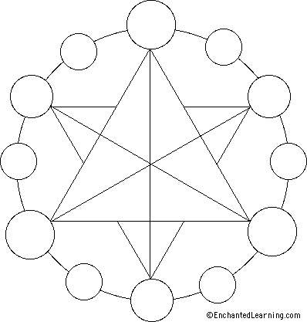

Activity 2 : Label Colour Complements

Use the definitions below to label and colour the colour relationships on the diagrams below:

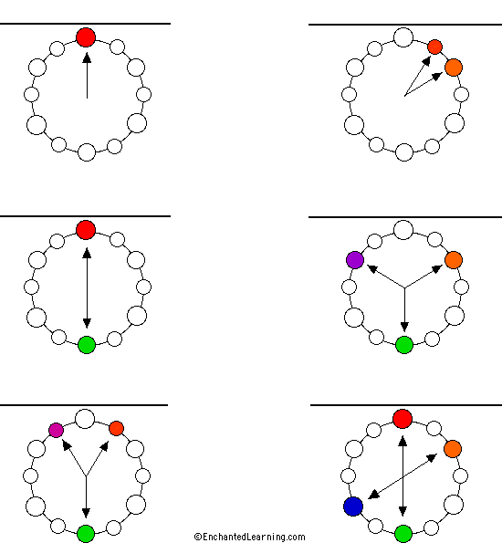

adjacent colours  complementary colours  double split complement | monochrome  single split complement  triad

Activity adapted from EnchantedLearning.com

